Project Title:
Deployment of a Dynamic Apache Web Application on Amazon EC2 with Static Media Hosting on Amazon S3
1. Introduction
This project demonstrates how to deploy a dynamic web application using Apache HTTP Server on Amazon EC2, while hosting all static media assets (images, CSS, JavaScript) on Amazon S3.
This architecture is widely used in industry because it improves performance, reduces compute cost, and allows scalable, secure separation of dynamic and static resources.
2. Objectives
The main goals of this project are:
- Deploy a dynamic PHP-based web application on EC2 with Apache.
- Configure an S3 bucket to host static resources.
- Assign proper IAM roles to allow EC2 to access S3 securely.
- Configure Security Groups and networking for web access.
- Validate the integration with browser testing.
- Understand cloud-based hosting architecture.
3. AWS Services Used
Service | Purpose
Amazon EC2 | Hosts Apache + PHP dynamic web server
Amazon S3 | Stores static files (images, CSS, JS)
IAM Role | Grants S3 access permissions to EC2
Security Groups | Controls inbound traffic
VPC | Underlying network infrastructure
EC2 Instance Connect | Used to access Linux instance
4. Architecture Diagram
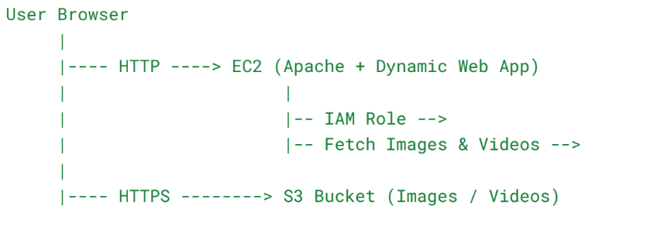 5. Step-by-Step Implementation
5.1 Create S3 Bucket for Static Media
- Navigate to AWS Console → S3
- Click Create bucket
- Enter unique bucket name
Example:
- static-media-demo-001
- Disable Block all public access
- Acknowledge the warning
- Create bucket
Upload Static Files
- Upload images, CSS, JavaScript
- Confirm Object URLs are accessible
Set Bucket Policy
{
"Version": "2012-10-17",
"Statement": [{
"Effect": "Allow",
"Principal": "*",
"Action": "s3:GetObject",
"Resource": "arn:aws:s3:::static-media-demo-001/*"
}]
}

5.2 Create IAM Role for EC2-S3 Access
- Open IAM → Roles → Create role
- Select:
  - AWS Service
  - EC2
- Attach policy:
- AmazonS3ReadOnlyAccess
- Name the role:
- EC2-S3-ReadRole

5.3 Launch EC2 Instance (Apache Server)
- Go to EC2 → Launch Instance
- AMI: Amazon Linux 2
- Instance Type: t2.micro
- Create/Select Key Pair
- Configure Security Group:
Type | Port | Source
SSH | 22 | My IP
HTTP | 80 | Anywhere
- Under Advanced Details, attach IAM Role:
EC2-S3-ReadRole
- Launch instance

5.4 Configure Apache and PHP on EC2
Connect using EC2 Instance Connect and run:
sudo yum update -y
sudo yum install httpd -y
sudo systemctl start httpd
sudo systemctl enable httpd
Install PHP:
sudo amazon-linux-extras install php8.0 -y
sudo systemctl restart httpd

5.5 Create Dynamic Web Page on EC2
Navigate to web directory:
cd /var/www/html
sudo nano index.php
Insert the PHP code:
<!DOCTYPE html>
<html>
<head>
<title>AWS Dynamic Web App</title>
<link rel="stylesheet" href="https://static-media-demo-001.s3.amazonaws.com/style.css">
</head>
<body>

<h1>Dynamic Apache Web Application on AWS</h1>

<p>Current Server Time:
<?php echo date("Y-m-d H:i:s"); ?>
</p>

<img src="https://static-media-demo-001.s3.amazonaws.com/image.jpg" width="300">

</body>
</html>
Set permissions:
sudo chown apache:apache /var/www/html/index.php

5.6 Testing the Application
Open browser:
http://<EC2-Public-IP>/index.php
Verify:
✔ Dynamic PHP output
✔ Image loads from S3
✔ CSS loads from S3
✔ Apache server is running
6. Results & Observations
- The dynamic page loads successfully from EC2.
- Static resources load directly from S3 URL.
- EC2 access to S3 is secure through IAM Role.
- Server time updates dynamically through PHP.
- Bucket policy allows public read-only access for static files.
7. Challenges Faced
Issue | Cause | Solution
403 Forbidden from S3 | Missing bucket policy | Added public-read policy
Website not loading | Port 80 blocked | Updated Security Group
PHP code visible | PHP not installed | Installed PHP packages
Missing IAM permissions | IAM role not attached | Reattached IAM role
8. Conclusion
This project successfully demonstrated:
- Deployment of a scalable dynamic web server on EC2.
- Separation of static and dynamic content for performance optimization.
- Proper use of IAM roles for secure resource access.
- Hosting static files on S3 to reduce cost and load on EC2.
- Secure configuration using Security Groups and bucket policies.
This architecture is widely used in real-world cloud deployments and forms the foundation for more advanced architectures like Auto Scaling, Load Balancing, and CloudFront CDN integration.

************************************************************

